**ECON 234: Wealth and Poverty of Nations (Thorsten Rogall)**

**LECTURE 1: INTRODUCTION**

Defining the problem:

1. Poverty

How rich are the rich? How poor are the poor?

Where do riches come from?

What keeps the poor from becoming richer?

2. Inequality

Inequality of what? Between whom? How much inequality?

Types of Inequality: Inequality among countries, within a country, and among people in the entire world.

Inequality within a country:

-In some countries, wealth is very concentrated among a few individuals. We think of these countries as “unequal.”

-In others, wealth is distributed more widely. WE think of these as relatively “equal.”

-The “Gini Coefficient” is a measure of income inequality:

0 represents perfect equality (income equally distributed among population)

1 represents perfect inequality (one person gets everything, everyone else gets nothing)

Values closer to 1 represent unequal societies, values closer to 0 represent relatively equal

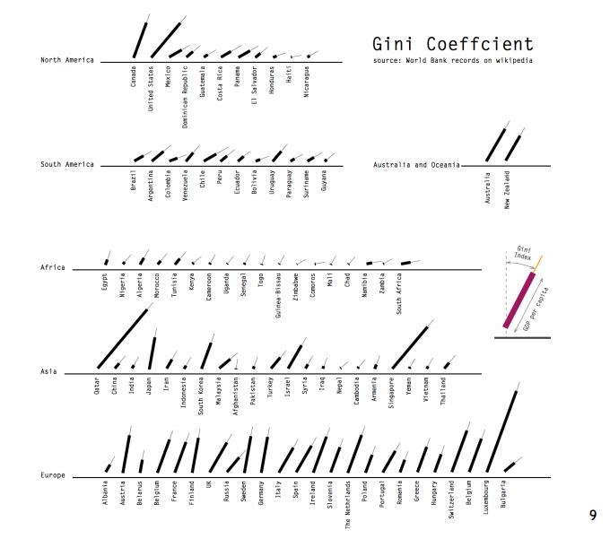

Causes of Poverty and Inequality:

1. Proximate (immediate) causes:

Immediate trigger. Eg. Why did he die? He had a heart attack.

2. Ultimate “deep” causes

Eg. Why did he die? He ate poorly and did not exercise.

What makes human societies different?

-Modern humans are essentially the same around the world. Race only reflects relatively recent external adaptations to the environment. Humans all descended from a single population originating in Africa circa 200,000 years ago and migrating out 70,000 years ago.

-Societies, technology, and wealth are different because of geography.

🡪 Anthropologist Jared Diamond postulates that Europeans came to dominate the world because of their geographical location endowed them with key advantages throughout history.

Diamond’s advantages of the West:

-Proximate:

Technology: Steel and Guns.

Disease environment: Immunity to germs

-Ultimate (ultimate)

-Orientation of continents allowed for easier spread of technology in Eurasia than Americas

-Biological “package” of domesticable plants and animals enabled better nutrition and

acquisition of immunity to diseases.

Institutions

-Institutions are rules that human societies can create for themselves.

-Hernando de Soto argues that developed countries successfully reduce inequality by granting widespread property rights to all members of society including the poorest ones.

De Soto’s Mysteries:

-The poor own a large amount of property, however cannot turn that property into productive capital due to legal systems, bureaucratic restrictions, and high transaction costs.

-Dead capital traps them into poverty.

Culture: A third explanation emphasizes cultural differences. (Religion, trust, habits, ethics, etc.)

**LECTURE 2: Poverty and Inequality**

-Poverty is defined as many things.

🡪 Poverty is hunger, lack of shelter, not having a job, etc…

Measuring Poverty:

1. A relevant welfare measure:

-Monetary measures: income, consumption

-Vital Statistics: Life expectancy, infant mortality

-Nutrition

-Education

-Access measures: clean water, medical care

2. The threshold (poverty line)

3. An indicator:

-Incidence (headcount of people below the poverty line)

-Depth (distance from the poverty line)

-Severity (depth squared)

Absolute vs relative poverty

-Absolute Poverty measures the number of people (or households) living below the poverty line

-Kept unchanged across countries and time to facilitate comparisons

-Incidence of poverty is also considered a measure of absolute poverty

-Relative Poverty measures the number of people below a threshold set in relation to a specific country

-Example: the number of people earning less than 50% the median income

National Poverty Lines:

-Set by official agencies in each country to estimate the number of people considered to be living on low incomes. Statistics Canada defines Low Income Cut-Offs (LICOs) as the income level at which a family needs to spend 20% of its income more than the average family on food, clothing and shelter.

-Helpful to track the evolution of poverty by standards of an individual society, but are not very useful for international comparisons.

Purchasing Power

-In order to compare monetary values across national borders, it is necessary to adjust them for purchasing power. (eg. A US haircut costs $18 while the same haircut in India costs $0.25)

-Market Exchange Rate is the number of units of a country’s currency required to buy one US dollar on the international currency market.

-Purchasing Power Parity (PPP) Exchange Rate is the number of units of a country’s currency required to buy the same amount of goods and services in the domestic market as one US dollar would buy in the US.

🡪 Can be calculated by dividing the price of a good in foreign country by the price of the same good in the US. Each price should be in the currency of the respective country.

Problems with the PPP

-It is very hard to construct internationally comparable consumption baskets.

-Not all goods are available in all countries

-The quality of the same type of good might vary across countries

-Consumer preferences for a given good might be different across countries

-Not all countries provide reliable price statistics

-True PPP exchange rates are revised only once every several years

Big Mac Index

-Big Mac is an internationally comparable good found in many countries.

-Its production requires many different food items, packaging, local labour, and rent.

-When a PPP rate is below market rate, the currency is undervalued.

“Penn Effect”

-Richer countries tend to have higher price levels.

-The price of tradable goods cannot vary much by location 🡪 known as “Law of One Price”

-Non-tradable goods use a large share of local inputs

-In higher income countries, the marginal productivity of labour is higher than in low income countries

-A high MPL implies two things:

🡪 High wages

🡪 High Prices of products containing a relatively large share of labour input.

Raw Numbers vs Incidence

-International comparisons require the use of absolute poverty figures at PPP exchange rates.

-Absolute poverty can be given as

-Raw figures: the total number of people below the poverty line

-Incidence: The percentage of population below the poverty line

-The use of raw figures vs incidence is one of the main sources of disagreement in interpreting the evolution of poverty

-In the presence of high population growth, the percentage of the population below the poverty line can go down at the same time as the total number of poor people increases.

Income Distribution

-Poverty reduction is a key policy goal in its own right.

-Another important policy dimension is the distribution of income.

-Income inequality is not bad however, most growth processes are characterized by an increase in inequality.

-One rough way of accessing income inequality is to look at the top income shares; these are defined as the amount of income claimed by the top X% of income distribution.

-Comparing distributions of income is difficult.

Lorenz Curve

-Plot of the income shares by percentile is a Lorenz Curve

-Under perfect equality the Lorenz Curve is 45 degree line

-The more the Lorenz Curve bows away from the 45 degree line, the more unequal the distribution

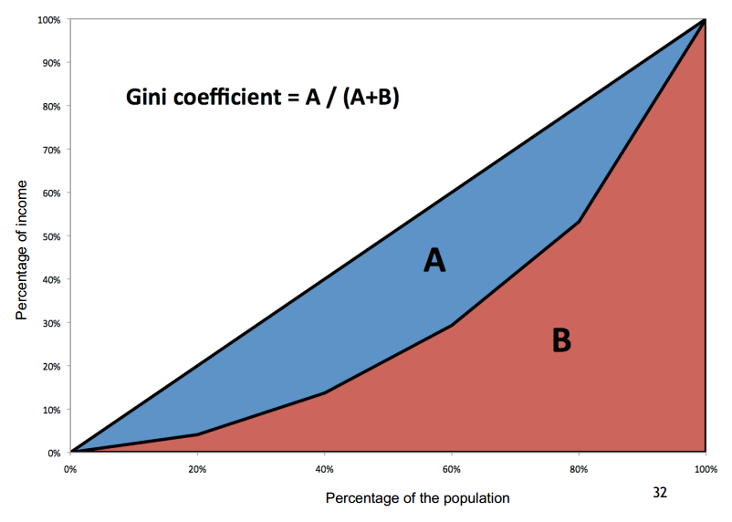

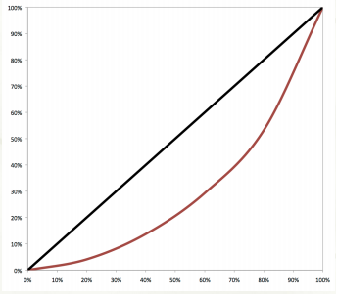

-Gini Coefficient is defined as the ratio between two areas:

-Area between 45 degree line and Lorenz Curve (A)

-Area under the 45 degree line (A+B)

-If the distribution is perfectly equal, the Lorenz Curve is equal to 45 degree line. (Gini = 0)

-If the distribution is perfectly unequal, the Lorenz Curve follows horizontal axis (Gini = 1)

Inequality and Development:

-1955 Simon Kuznets conjectured that as a country started development, inequality would first rise then decline.

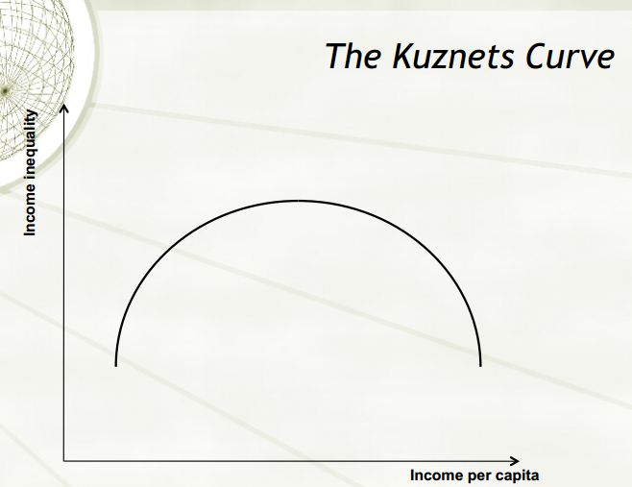

-Inequality across countries continues to increase.

-Common mistake is focusing on the dollar gaps rather than relative incomes.

Philosophical Issues:

-People do not care only about economic efficiency.

-In most cultures and individual value systems, fairness plays an important role.

-Because conceptions of fairness vary, so will ways of valuing welfare of different sectors of population.

1) Extreme Criteria

-Extreme efficiency criteria would want to maximize total income of population

🡪 This would make it acceptable to take away from the poor as long as rich gained more than poor lost.

-Extreme egalitarianism regards any deviation from full equality as negative.

🡪 Prefers a situation where everyone earns 1 dollar to case where 1% of population earns 10 dollars and 99% earns 20 dollars.

2) Pareto’s efficiency criterion

-Requires any movement away from the current situation make no one worse off, while making at least somebody better off.

3) Rawl’s criterion of Justice

-John Rawls coined an egalitarian standard stating that increases in efficiency are only desirable if they make the poorest members of society better off. (increases the poor’s standard of living)

Conclusion:

-World poverty has fallen dramatically the past 30 years

-Effect of growth on inequality depends on the stage of development

-Inequality is not necessarily bad

🡪 Initial stages of growth processes may require an increase in inequality

🡪 Further normative evaluation of inequality depends of the philosophical criterion being used.

**LECTURE 3: Inequality II**

Review:

-Inequality within a country is usually measured in two ways:

i) Top Income Shares: Top percentage of the country’s income that goes to the X% richest

portion of the population

ii) Gini Coefficient: A summary measure of income distribution calculated using Lorenz

Curves

The Keira Knightly Connection

-One way of comparing inequality of past societies to modern ones involves asking how much money was necessary to move up the next income percentile. Conversely, by how many percentiles would one move up if one’s income increased by a fixed amount.

Pride and Prejudice:

-Elizabeth Bennet (1/5 sisters in British Family circa 1810) whose father makes 3000 pounds/yr, putting him at top 1% of incomes. If her father dies, Elizabeth unmarried, inheritance of the money goes to his cousin. Elizabeth would survive on 50 pounds/yr placing her at British Median Income.

-Mr Darcy makes 10,000 pounds/yr 🡪 top 0.01%. If Elizabeth marries him, her share would be 5000.

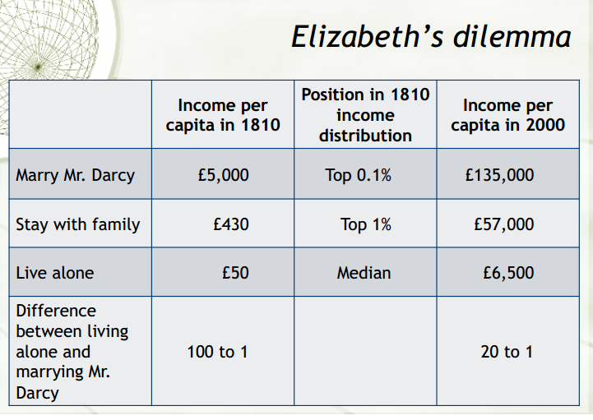

Anna Karenina

-Lives on 200 rubles/yr (65th percentile)

-Marries Mr. Karenin, a civil servant earns 9000 rubles/yr 🡪 top 1%

-Count Vronsky has income of 100,000 rubles/yr 🡪 top 0.1% higher

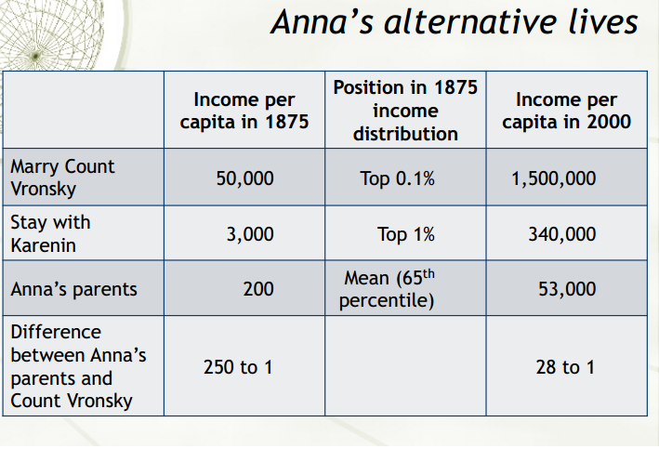

Comparing the Rich in Different Times

-PPP and inflation adjustments do a poor job of comparing income through time.

-Different bundles of goods

-Different qualities

-Different technologies

-One way of comparing purchasing power is asking how many unskilled persons could a rich person employ with his income, in his country, at the time in which he lived.

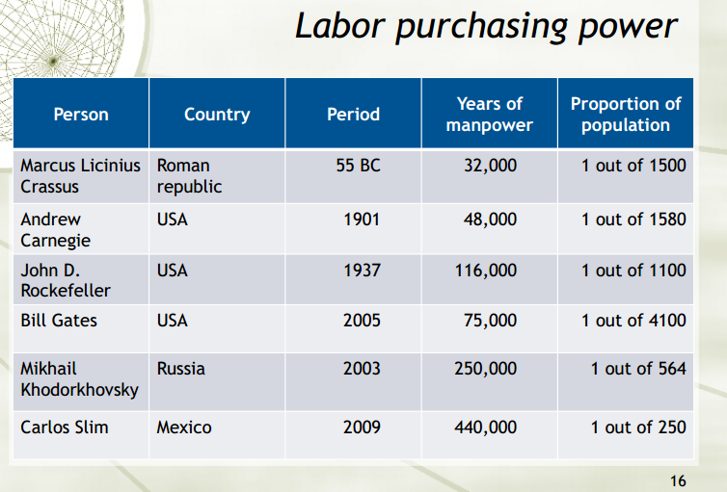

Income Inequality through history:

-Elizabeth Bennet and Anna Karenina’s lessons are a constant throughout history.

-Income inequality today is much lower than just a century and a half ago.

-This phenomenon is most visible in industrialized countries. Developing countries still have high inequality.

-The benefits of industrialization and economic growth have, in relative terms, accrued mostly to the poor.

-While the rich are still rich, the working classes have gone from mere subsistence to comfortable lives.

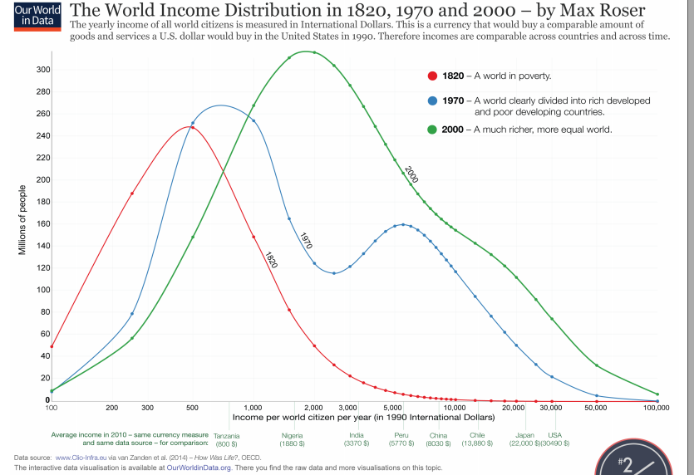

Roman Inequality:

-The gap between the poor and rich was enormous. A top income shares approach tells us that inequality was very high.

-Because the vast majority of population earned roughly the same (low) amount, the Gini coefficient was not very high.

-Problems with the Gini Coefficient

-Collapses a 2D distribution into a single number

-Thus, two very different income distributions can end up having the same Gini.

Inequality under socialism

-The premise of socialist systems was to collectivize the means of production and spread their fruits equally.

-Socialist countries should therefore have achieved greater equality than capitalist ones.

🡪 Gini Coefficients of socialist countries were 6-7 points lower than comparable capitalist countries.

How was this achieved?

1. Nationalization of means of production and natural resources (severe reduction in top incomes)

2. Full employment (everyone had an income)

3. Universal education, but very small differences in compensation for those with post-secondary

4. Welfare transfers dictated only by demographic characteristics

Costs of Equality

1. No returns to entrepreneurship took away incentives to innovate

2. No returns to education took away incentives to learn more

3. No returns to effort resulted in low productivity and slow growth

Socialist Inequalities

1. Political in nature (good jobs went to those with party connections)

2. Jobs paid little, but had benefits and perks attached 🡪 this ensured party loyalty

-While inequality was not high, the perception of it was

Effects of Redistribution:

-Market Income: Income received from wages, profits, interests, rent, etc. (before taxes/transfers)

-Disposable Income: Total income after taxes and transfers “spend money”

-Usually fiscal redistribution means:

-poor end up with higher disposable income than their market income (subsidiaries/transfers)

-disposable income of the rich was lower than their market income (because of taxes)

Theory: The Middle Class Should Gain More

-3 classes (poor, middle, rich)

-Poor want more redistribution, rich want less

-Middle class is pivotal voter

Reality: ONLY the poor gain:

-Poor gain consistently through fiscal redistribution

Example: In US, bottom 10% income distribution has market incomes of 1.2% national income

After redistribution, increases to 4.1%.

Why middle class doesn’t gain?

1. Insurance (they contribute to fiscal redistribution for the poor just in case they need it in future)

2. Kind Transfers (Fiscal redistribution does not take the value of education and healthcare, and the middle class is the largest beneficiary of state-subsidized education and healthcare)

3. Voting Patterns reflect values and ideals, rather than strict economic gains.

Fiscal Federalism:

-Federations are held together by transfers from rich regions to poor ones.

-This only works when differences are not too great.

-In US rich states are only 1.5 times richer than poorest ones

-In Spain the gap is 1.7

-In Italy (Large inequalities) it is 3 to 1.

-Federations only work when the benefits of staying in outweigh the costs.

-Inequality increases the cost for rich regions to stay in, while reducing their benefits.

Types of Regional Inequality:

1. American Style: More or less the same proportion of rich and poor people across country

2. Socialist Style: Rich concentrated in some areas, poor in other. 🡪 Politically unstable

-In China, the ratio between the richest and poorest provinces is at least 10 to 1.

Conclusion:

-Inequality within countries has declined markedly in recent history.

-Cross time comparisons are tricky. There is more to wealth than monetary units.

-Socialist economies succeeded in reducing inequality, but at the cost of dramatically lowering productivity and growth.

-Regional inequality is a serious challenge to national identity

🡪 Break up of USSR and Former Yugoslavia

🡪 Increasing regional inequality in China.

**LECTURE 4: Inequality among Countries**

-Economic Theory predicts that increasing globalization should benefit poor countries the most.

-Capital is scarce in poor countries. This makes the returns to capital quite high.

🡪 Openness should attract foreign investments and foster growth.

-Poor countries don’t have to incur the cost of invention and innovation (they can import the latest technology called Leapfrogging)

Economic Reality on Global Inequality

-International investment flows mostly between rich countries

🡪 Lucas Paradox has 2 possible explanations

1. Institutions: poorer countries have a higher risk of expropriation (taking property from owner for public use).

2. Complementarities: Capital needs to be complemented with adequately trained workforce

Technology Adoption:

-The adoption of technology in developing world is much slower than economic theory would suggest.

-The protection of intellectual property rights is partially to blame as patented technologies cannot be legally adopted without paying royalties, which are often unaffordable in developing countries.

-Complementarities are possible. It is not sufficient to just adopt the technology. It also requires skilled human capital to install, operate, and maintain it.

-A lot of wealth and population in 1 A.D was in Europe and Asia, however, the Wealth today has shifted to the Western World, while population still remains large in Eurasia.

Karl Marx:

-Marx observed England between 1840s and 1870s when Industrial Revolution was at its peak.

-Workers were earning close to subsistence wages and living in poor conditions in unhealthy cities.

-Large capitalists were accumulating large fortunes.

-Marx concluded that capitalism would lead to evermore unequal societies which ultimately lead to class struggle and revolution.

-Around 1870, the British Workers began experiencing increased living standards.

-By 1914, working classes in industrialized countries were living comfortably above subsistence levels.

-Engels’ Pause: 1790-1850 wages stagnated while profits grew.

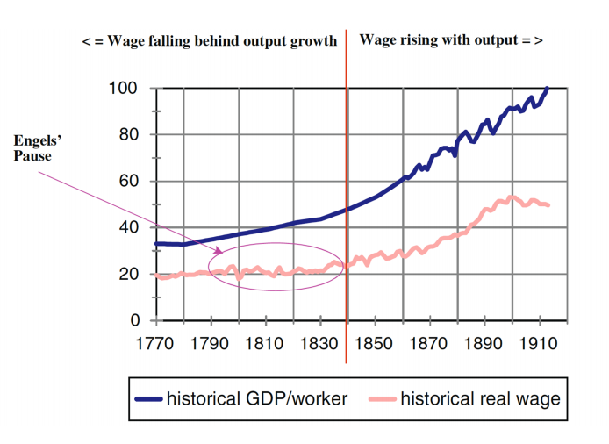

-The industrial revolution saw a massive transformation from land-based technologies to capital-based ones.

-At the beginning, there was very little capital. The new capital intensive technologies created a capital premium, thus increasing profits. Labour remained low. Once industries were sufficiently capitalized, returns to labour and capital started growing at the same rate.

Proletarian Revolutions:

-Workers whose standard of living are going up are not interested in revolutions.

-Workers whose standard of living are high do not identify with workers in poorer countries.

-Communist revolutions only happened in countries that had not previously industrialized (Russia, China, Vietnam, Cambodia)

-This was in stark contrast to Marx’s predictions. Marx saw communism as following capitalism.

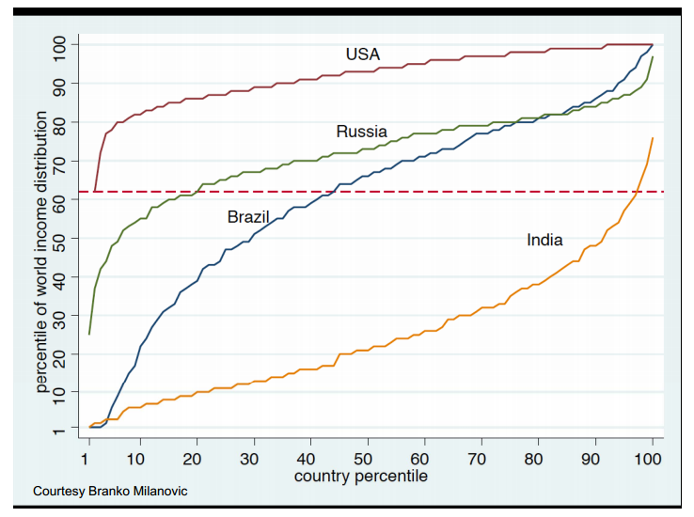

-The bottom 5% Americans sit at 68th percentile of world income distribution, approximately where 5% of top Indians rank.

Birth:

-Being born in US guarantees you a higher income than 97% of all Indians.

-80% of an individual’s income is explained by country of birth and parent’s socioeconomic status.

-20% is explained by variables under no control (gender, race, age, luck) and control (effort)

Three Generations of Obamas:

-Hussein Onyango Obama (Grandfather)

- Domestic Servant for White British Colonists

- Salary 720 shillings/year; was at top 10% earners

- Subsistence income was about 137 shillings.

- Asians in Kenya earned 3000 shillings, Europeans earned 16,000 shillings.

-Barack Hussein Obama Sr. (Father)

- Earned M.A Economics at Harvard, went back to Kenya work as government economist

- Africa’s economies grew at a slower pace than the rest of the world and income gaps widened enormously.

**LECTURE 5: Inequality among People in The World**

-To measure inequality, each country’s inequality should be weighted by its population.

-Weighing by population has the effect of treating each individual equally, rather than each country equally.

-The problem with measuring inequality is due to the quality of surveys and accuracy of surveys.

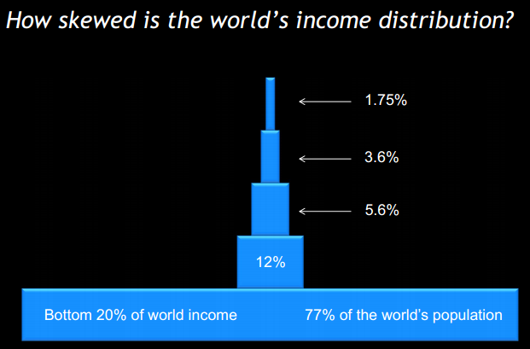

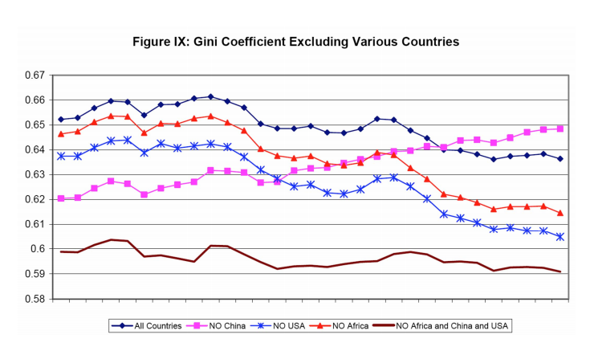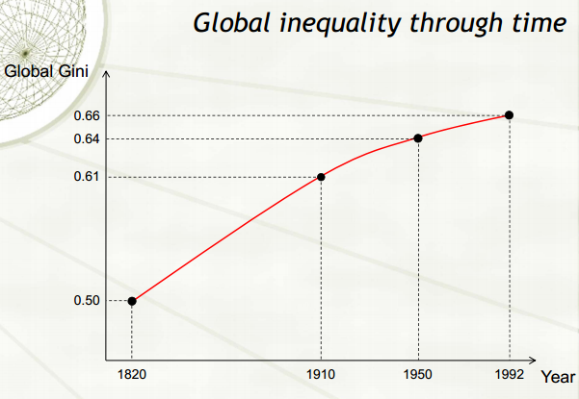

Does global inequality matter?

-One view is that we should not concern ourselves with inequality at the global level.

-Inequality does pose global problems:

- Large inequalities spur mass migrations from poor to rich countries.

- Unrest in poor countries can quickly spill over to the rest of the world.

- Poor sanitation in poor countries can spark global pandemics

Trilemma of Globalization:

1. Increasing globalization

2. Large inequality across countries

3. Limited Migration

🡪 It is not possible to continue on all three for long. Only two can coexist in the long run:

a) Increasing globalization paired with inequality will increase migratory pressure

b) Continued large inequality without migration will require globalization to be scaled back

c) Increasing globalization and limited migration will require the reduction of inequality

Is there a global middle class?

-Milanovic defines the “middle class” as the group of people whose incomes are within 25% of the national median. However, is a rough approximation and does not allow for regional differences.

-Developed countries have around 40% of their population in the “middle class.”

-By Milanovic’s definition, the world’s middle class comprises about 850 million people; 15% of population.

🡪 Median is a more appropriate term to define the relative poverty in which the median range of the world population lives.

-That the median of the world is so poor reflects high level of global inequality.

The US vs. The EU

-United States and European Union (as a whole) have roughly the same Gini Coefficient ~ 0.4

-This doesn’t mean their income distributions are the same however:

- The US have very little between state inequality (richest state is 1.5x richer than poor)

🡪 Strong within state inequality

-The EU has low within country inequality.

🡪 Richest country is over 7x richer than poorest one

Latin America vs Asia:

-Latin America (overall Gini = 0.65)

-Relatively little across country inequality

-Relatively large within country inequality

-Asia (overall Gini = 0.60)

-Relatively large across country inequality

-Relatively little within country inequality

Crisis of 2007-2009 : A Timeline

-During the 1990s and early 2000s, a policy of low interest rates fueled a lending boom in the US Saving rates dropped and consumer credit increased.

-The 2000s were a time of relaxed regulatory oversight. In particular, investment banks and hedge funds were allowed to operate without the strict oversight that commercial banks are subject to.

-A wide variety of unregulated financial derivatives were introduced. The vast majority of market actors did not understand very well how they worked.

-The fastest growing lending instrument were subprime mortgages:

-Extended to people who did not qualify for a regular mortgage

-Higher rates (but still low)

-Subprime mortgages were “packaged” into financial derivatives called “collateralized debt obligations” (CDOs)

-These CDOs were given AAA grades by rating agencies. Also widely marketed internationally.   
-Many buyers of CDOs also bought insurance for them in the form of credit-default swaps.

Why were CDO’s AAA Rating?

-Banks packaged a large number of subprime mortgages into a CDO

-CDO is divided into a number of “tranches”, which are sold separately.

Suppose CDO is divided into 10 tranches:

-First 10% if payments received from the entire pool of mortgages goes to pay investors in 1st tranche; second 10% pays 2nd tranche, etc..

-As long as the 10% mortgages are in good standing, you will get paid.

-If you invested in 2nd tranche, you need 20% of mortgages to perform to get paid, etc.

-Credit rating agencies gave AAA ratings to the best tranches of CDOs normally top 50%

-Banks sold the top tranches and kept the tranches not rated AAA themselves off balance sheets.

The Crisis:

-Fed eventually began tightening monetary policy in 2005.

-Subprime mortgages had variable rates and became more expensive.

-Bottom tranches of CDOs underperformed

-Once a CDO is sold by the bank, it is very difficult for the next owner to determine what types of assets are packaged with it.

-With defaults rising, many did not wish to risk buying CDOs with uncertain assets in them. As a result, the market for CDOs froze and nobody wanted them.

-Banks began to heavily rely on restricted credit. As credit became scare and more expensive, businesses started to fail, unemployment rose at a fast pace, and consumer demand plummeted.

Inequality and Crisis:

-Increasing income inequality creates a rich class with excess cash, looking for profitable investments. It also creates a poorer middle class longing for the standard of living of the rich.

-Lack of regulation prompted banks to take excess savings of the rich and lend them to finance the consumption of the middle class.

-No actual productivity gains were associated with the increase in consumption.

-In Milanovic’s view, the main culprit of the crisis were 30 years of rising inequality without increases in income.

-Recall: The maximum possible Gini coefficient is 1, were 1 is most unequal and 0 is most equal.

-If a large % of population earns barely enough for survival, the elite cannot extract much. This society is very equal.

-As a large % of population earns more than subsistence income, elites can extract more and more and society can become more unequal.

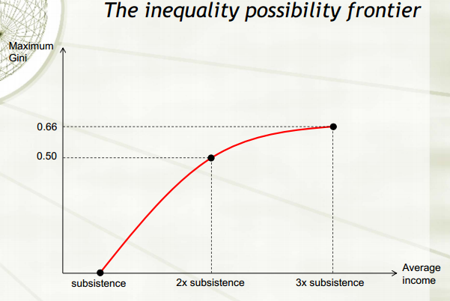

Conclusion:

-2nd world disappeared with the fall of communism

-3rd world split:

-Some countries became richer and joined the 1st world

-Latin America continued ideological polarization and economic policies characterized 3rd world

-Other countries remained poor and war-torn (4th world)

**LECTURE 7: Economic Growth (Solow’s Model)**

-Economic growth is defined as the increase in the amount of goods/services produced by an economy over a certain period.

-In order to measure growth, we need to measure Gross Domestic Product (GDP)

-GDP Per capita is the average amount of goods/services an economy produces for each inhabitants

-GDP captures the value of transactions in the formal economy, but not the informal and home production. Also does not capture measures of human welfare such as health.

-GDP is good at approximating material living standards in an economy.

-Production Function:

**Y= A* f (K, L)** which can be rewritten as y = A*f(k), y=Y/L, k=K/L, L/L

Y = total income

K = Capital

L = Labour

A = Technology

-Income can grow in two ways:

1) Increasing factors of production (capital and labour)

2) Increasing technology

-Intuitively we cannot increase income per capita by increasing labour, as it can cause decreasing returns to labour.

-Harrod-Domar Model:

- Savings are transformed into investment, which becomes capital

- Capital accumulation leads to more capital per capita and more income per capita

-Increasing capital while holding labour and technology constant, we get decreasing returns

🡪 Additional machines cost more than additional output generated

-The only way to achieve sustained economic growth is by improving technology.

-Often assume constant returns to scale: Multiply all inputs by a constant and output will increase by the same constant.

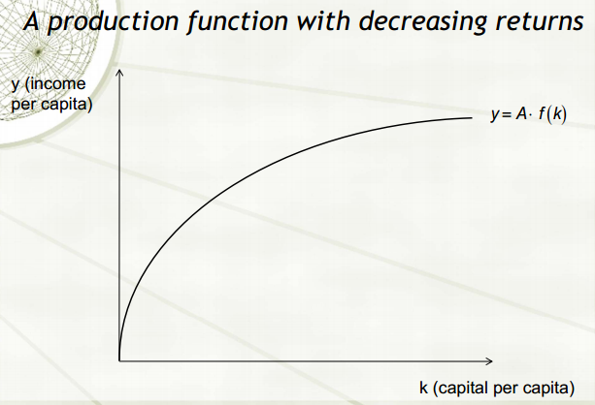

-Capital depreciates over time, and new capital is formed through investment. Investment is funded through savings.

-Let s be the constant portion of total output economy saves each year.

Gross Investment: **s * y = s * Af(k)**

Net Investment: **s* Af(k)- 𝛿k**

**-**Net Investment is Gross Investment minus Depreciation

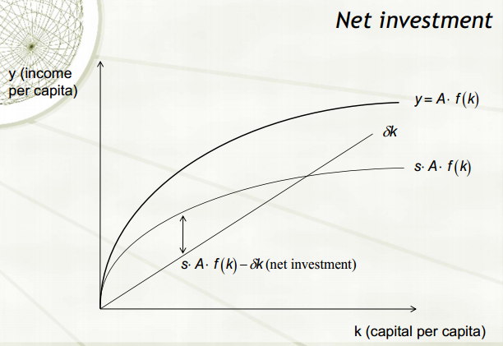

-When **s* Af(k) > 𝛿k ,** capital is being accumulated

-When **s* Af(k) < 𝛿k**, stock of capital decreases

-When **s* Af(k) = 𝛿k**, stock of capital is unchanged. 🡪 Steady state (no growth or output)

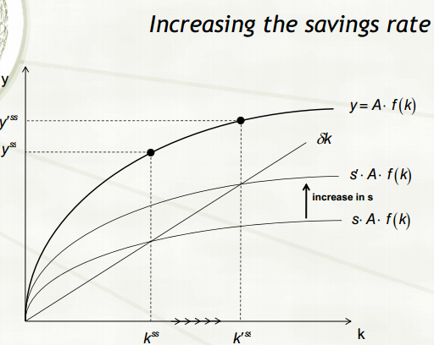

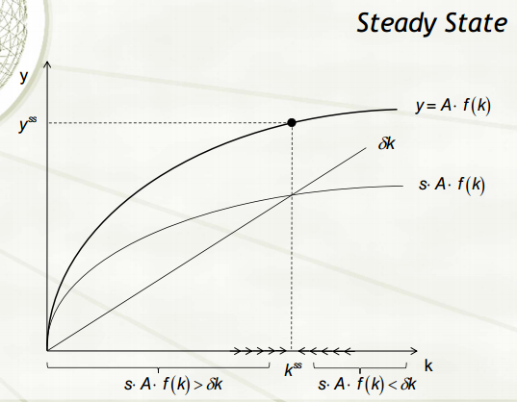

-An increase in savings rate shifts the **s* Af(k)** curve upwards. This results in a new steady state with a higher level of capital per capita and income per capita.

-The growth here is transitional, meaning it only lasts while the economy is adjusting to the new steady state. Once adjusted, the growth stops.

-New technology allows us to produce more output with the same amount of inputs

-An increase in technology shifts the production function and savings curve upwards.

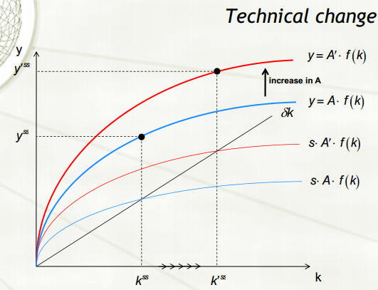

-The economy can continue to grow as technology increases.

Creative Destruction: While technical change increases overall productivity, some people find that their skills are made obsolete by the new technology.

-Creative Destruction renders skill and capital obsolete, even as it gives rise to new industries and new jobs. People with vested interests in the old technologies will resist innovation.

a) Protectionism

b) Employment quotas (minimum number of workers to perform a task)

c) Technology bans

-Vested interests are usually stronger in most technologically advanced countries.

-This often allows for countries behind the technological frontier to jump ahead of the leader 🡪 leapfrogging

🡪 However, leapfrogging requires the ability to invest in new technologies and operate on them

-The countries most likely to leapfrog are those just behind the technological frontier

Technology Creation:

-Goods are rival in consumption, whereas Technology is not.

🡪 Once invented, technology can be used by anyone.

-Inventors find it hard to fully appropriate the profits from their inventions.

-To reduce the problem of imperfect appropriability, governments grant and enforce patents

🡪 Patents are time limited monopolies over an invention, which also forces inventors to fully disclose details of their invention.

Human Capital:

-Workers with higher human capital command higher rewards in labour market.

-Healthy people are more productive (sick spend time recovering)

-Richer people can afford better living conditions and better healthcare, therefore live longer

-Education is the main form of human capital. There are problems such as different quality of education and credential issues.

-In developing countries, returns to human capital account for half of total wages

-In developed countries, returns to human capital account for 65% of total wages

**LECTURE 8: Up To The Starting Line (Geography I)**

-New Guinea peopled 40k years ago

🡪 Wide Variety of Climates and Ecosystems; huge biodiversity

🡪Home to 1000 of the world’s remaining 6000 languages

-Yali’s Question: “Why is that you white people developed so much cargo and brought it to New Guinea, but we black people had little cargo of our own?”

-Jared Diamond expands on this: “Why did Europeans conquer the rest of the world and not anyone else?”

🡪 Common Answer: “Race.” Some races are smarter, more productive, or just better than others.

Debunking the Race Myth:

-Diamond argues that New Guineans are at least as smart as Westerners (probably even smarter)

-Biggest killer in the West was diseases (which do not select who they kill)

-Childhood stimulation is better in primitive societies (no TV)

-IQ tests are culturally conditioned

-Western Educational Systems train people to perform well in tasks and thinking in IQ tests

-Visible differences across races 🡪 Genetics

-200 kya: Our species emerges and spread out in Africa

200-100 kya : Humans diverge genetically within Africa

-We share 97-99% of our DNA with chimpanzees

🡪 Groups began spreading out and leaving Africa and adapt locally

-Humans are less genetically variable than chimpanzees, most human genetic variation takes place within populations

-Average genetic differences between races are much smaller than the genetic variation across individuals of the same race.

- “Race” is relatively recent local adaptations in the environments.

- Latitude: cooler climates are more favourable for development

-Europeans prevailed over other peoples because of their superior military technology, metal tools, and resistance to deadly diseases.

BUT WHY DID THEY LEARN TO MANUFACTURE METAL TOOLS AND POWERFUL WEAPONS BEFORE OTHER CIVILIZATIONS? HOW DID THEY DEVELOP IMMUNITY TO DISEASES?

-Diamond attempts to answer this by starting 11,000 BC

🡪 People began evolving and moving around becoming more skilled and smarter.

-Foragers in Upper Paleolithic survived on hunter-gathering, small bands, egalitarian and acephalous (no leader)

-Later Paleolithic peoples coped better with the environment, had longer life spans, well nourished

-In Australia and Americas, many large animals disappeared with the arrival of humans.

-African Megafauna co-evolved with humans

Conclusion:

-Starting Line: 13,000 years ago when all continents were populated, end of the last ice age, start of village life in some places, all societies were hunter-gatherers.

**LECTURE 9: The Haves and Have Nots of History**

-The Maori arrived in New Zealand from Cook Islands around 1000 AD. They were farmers and fishermen. Upon arriving in New Zealand, they reverted back to hunting and gathering, driving Moa to extinction. Before 1500 AD a group separated and found Chatham islands becoming the Moriori.

🡪 Maori evolved complex chiefdoms and kingdoms. Formed hierarchical organizations and intensive farming practices fed large populations. They had complex technologies, craft specialists and division of labour.

🡪Agriculture was not possible for the Moriori; reverted to fishing and foraging. They had small populations, simple technology, little warfare, and no specialists.

-Ultimately, Maori arrived and killed off all the Moriori.

🡪 The root of differences between them cannot be genetic or deep culture. The big difference was the environment they lived in and the resources available to them.

The Austronesian Expansion:

-A distinct Polynesia cultural complex had developed by 3000 BP

-Indonesia and Philippines were inhabited for foragers going back at least 40,000 years.

-Island Melanesia and horticulturalists had some societal complexity

-The interior of New Guinea had complex warring societies

-Hawaii

🡪 Ruled by kings at the island level

🡪Classes and division of labour (warriors, craftsmen, labourers, sailors, priests)

🡪Large scale irrigation, productive agriculture

🡪No metal or writing

-Tonga

🡪Birthplace of Polynesian cultural complex

🡪Had developed into a maritime empire by the time of European arrival

🡪Conquered many Fijian island

-Small islands

🡪Independent villages (with weak division of labour)

🡪Weak chiefs

🡪Egalitarian

🡪Simple Populations and technology

Collision at Cajamarca

-Inca emperor dies from smallpox followed by death of eldest son and heir.

-Wars of succession break out

-Spanish soldier Francisco Pizarro set out with under 200 men to invade Inca

-Pizarro outnumbered 40x still defeated the Incas with careful ambush and newer and stronger technology including horses and gunners.

-Spaniards prevailed through the element of surprise, had guns/swords, horses + cavalry charge, germs

Proximate to Ultimate Causes:

-Stories of Maori conquest of the Chathams and Spanish conquest of the Inca empire help tie proximate factors to ultimate factors:

-Proximate: guns, germs, technology, military training

-Ultimate: resources, domesticable animals, food production

Diamond’s Model:

|  |  |
| --- | --- |
| C:\Users\Matthew\AppData\Local\Microsoft\Windows\INetCache\Content.Word\Untitled.png | -Unified model to explain broad historical patterns and current inequalities  -Predicts that most complex societies will evolve in Eurasia  -Big head start for areas with a wide variety of domesticable plants and animals |

The Importance of Domesticated Animals:

-Food, production of dairy, energy source, fertilizer (manure), expose people to germs, military advantage (horses)

The Importance of Agriculture:

-Farmed crops provide much more consumable calories per unit of area than foraging, enables higher population densities

The Importance of Sedentism:

-Births can be spaced tightly together, food surpluses can be stored (and support specialists)

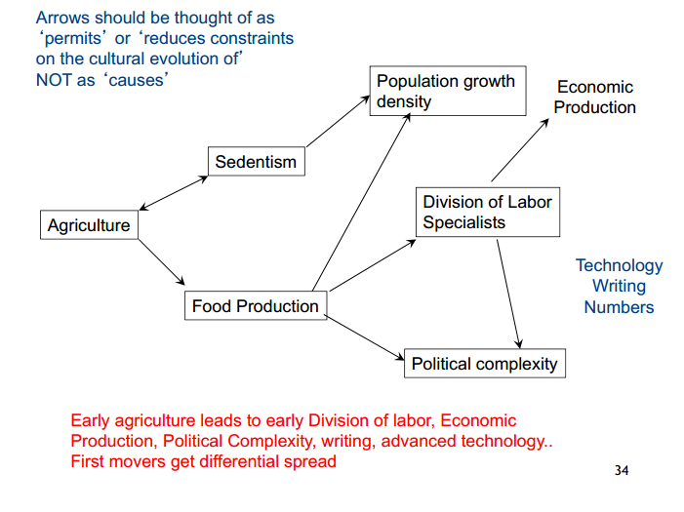

The Onset of Food Production:

-Food production appears very late in human history (only 10,000 years ago)

🡪 Appears independently in 5 distinct areas of the world:

-Fertile Crescent (Southwest Asia), China, Eastern US, Mesoamerica, The Andes

Conclusion:

-Original endowments of domesticable wild animals and plants vary greatly around the world

-Some areas developed food production early on (others trailed and other never developed)

-The areas that developed food production early on got a head start (then became the “haves”)

**LECTURE 10: Origins of Farmer Power**

-Agriculture appears independently in at least 5 different areas.

🡪 Appears first in the Fertile Crescent (9000 BC) followed by China and 3 sites in Americas

🡪After it begins spreading, some human groups convert to agriculture and others remain hunting

-The adoption of agriculture happens at different rates in different continents

Why doesn’t agriculture appear earlier?

-Start of agriculture coincides with transition of Pleistocene to Holocene

-End of the last ice age, warmer weathers, less windy (more stable weather)

-Agriculture takes time to develop, since you have to make genetic changes in plants/animals

-Reduced availability of wild foods (especially animals)

-Inventions in food collecting, processing, storing technology

Problems of Switching to Agriculture:

-Compared to their foraging predecessors, early farmers:

-lived shorter lives, got sick more, got attacked more, ate fewer preferred foods

-Modern ethnographic comparisons indicate

-less social/leisure time, more witchcraft beliefs

Agriculture has high population growth

-Foragers regulate reproduction as feeding them is costly and takes time to be productive. However, farmers have an average 1 child every 2 years as children are valuable farm labour, farming produces excess food which feed more people, farming success increases with large families.

🡪 Malthusian Trap: Eventually population grows too much, results in undernourishment.

-Farming benefits groups in competition with other groups (larger populations, control of land, surplus support militaries, craftsmen, etc.)

-As population grows with increases in agriculture, it is impossible to revert back to hunter/gatherer societies to support these large populations.

Packages:

🡪Essentials for life (carbohydrates, protein, essential amino acids)

Domestication:

-Plants and animals coevolved. Plants evolve to use or avoid animals. Many have protective shells or casings for their seeds, or were poisonous. Some plants used animals as dispersal mechanisms such as making the seed an attractive colour, or pass through the animal digestive system as fertilizer.

-Humans prefer larger, better tasting, less bitter seeds or fruit.

-Humans pick seeds that do not disperse or break open (easy to gather)

-Individual mutation of wild plants make them attractive to humans

-Humans compete with animals with different preferences.

-Humans became dominant form in evolution of certain plants (wild grasses, tubers)

-Other plants like fruits, are adapted to animals and domesticated much later

-Strawberries and Mangoes (Acorns were never domesticated)

Plant Features influencing domestication:

-Reproductive System

-Seeds

-Selfers (pollinate themselves)

-Self-incompatible hermaphrodites (cross pollination)

-Dioecious (male and female plant pollination)

-Reproductive Cycles

-Time from planting to germination

-Yield (how much genetic changes are needed to make plant productive?)

-Toxicity

-Many foragers weeded and cleared unwanted plants to allow desirable wild species to grow

Stages of Agriculture Adoption:

-Stage 1 (10,000 years ago): wheat, barley, peas

-Stage 2 (6,000 years ago): olives, figs, pomegranates, dates, grapes

-Stage 3: apples, pears, plums, cherries require grafting

-Over 200,000 species of flowering plants, today 12 plants yield 80% of total annual tonnage of crops. Not a single plant has been domesticated in last few centuries.

European/Middle East Advantage:

-Climate and Variety of Domesticable Plants and Animals

-Recall: Fertile Crescent has easily domesticated plants (pollinate themselves) and animals.

-Fertile Crescent had high yields, relatively high protein, storable, few genetic changes required to domesticate them (seeds already edible).

China

-Rice domesticated, water buffalo and pigs; goats, cattle, sheep arrive from Fertile Crescent.

Mesoamerica:

-Corn, dog; later beans and squash.

-Corn was less productive than wheat and barley. The reproductive system had to be changed. Genetic changes took thousands of years and corn was still not healthy.

USA:

-Sunflower, goosefoot, knotweed, maygrass, squash 🡪 replaced when corn, beans and squash arrived from Mexico.

New Guinea:

-Mostly root crops (Taro, yam). No cereals, lack of protein, limited altitude, no animals.

Apples or Indians?

-Evidence strongly suggests that Fertile Crescent was ahead of time because of the large concentration of edible grasses, few genetic changes required, complete package.

-When superior packages became available, farmers in other parts of the world readily adopted them.

Conclusion:

-Agriculture enables higher production growth and more complex societies.

-Fertile Crescent had a head start from climatic and biodiversity reasons.

-The European package was superior than other parts of the world in terms of meeting nutritional requirements of humans.

-Variation in adoption of agriculture by society is due to package availability, rather than to innate differences.

**LECTURE 11: From Domestication to Writing**

Recall:

-Agriculture enables higher population growth and more complex societies

- The Fertile Crescent had a head start for climatic and biodiversity reasons

- The European package was superior to those of other parts of the world in terms of meeting nutritional requirements of humans.

- Variation in the adoption of agriculture by society is due to package availability, rather than innate differences.

Animal Domestication:

-Humans began domesticating animals at the same time as they started domesticating plants.

-All the important domesticated animals are large mammals which provide dairy, wool, meat, hides, manure, transportation, power, etc.

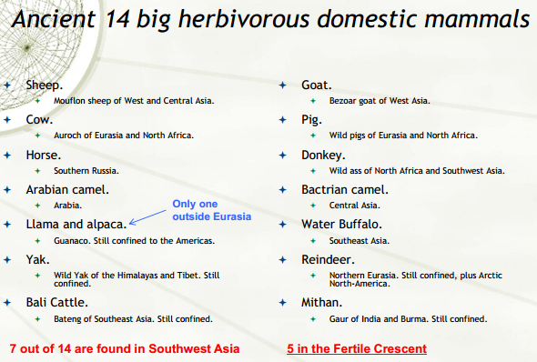

-Modifying an animal or plant species in ways useful to humans (behaviour, diet, physical, fertility)

-Taming consists in modifying the behaviour of a single individual caught in the wild.

🡪 Elephants were never domesticated, but were tamed. As were the bears, lions, cheetah.

-To be a candidate for domestication, Diamond examines 148 characteristics including wild, herbivore/omnivores, large weight, terrestrial. Eurasia had the largest number of overall candidates and the largest number of candidates domesticated.

-When domesticated animals reached other places, they were quickly adopted.

-Pets are very common.

-All large animals ever domesticated were already so by 2500 BC.

-The Anna Karenina Principle can be applied to animal domestication.

🡪 Zebras could not be domesticated because they bite and cannot be ridden

🡪Cheetahs cannot mate in captivity

🡪Gazelles panic

-Domestication characteristics:

1) Diet Efficiency (Cannot be picky, 1/10 herb, 1/10 * 1/10 carnivore)

2) Fast growth rate

3) Reproduce in captivity

4) Docile Disposition and not panic

5) Social Structure that can be replaced by humans

East-West Axis:

-Large extensions lie at the same latitudes. (Same length of day and approximately same climate across continents. The same crops and animals work all over).

-Allows for easier spread of food production, animal/plant species, germs.

North-South Axis implies latitude changes often. (Different lengths of the day, seasons, temp., Crops grow at one latitude will fail at the other).

-Major natural barriers (Andes, Rocky Mountains, Panama)

-Difficult to spread crops and technologies (the same crops had to be independently domesticated in different areas, some areas had to make do with inferior crops).

-Africa was close to Fertile Crescent, but Sahara is a barrier and so are tropical areas to the west.

🡪 West Africa independently domesticates tropical crops.

Roman Empire:

-Spreads quickly around Mediterranean.

-Fertile Crescent Package

-Expansion stops when pushing into Northern Europe, crops would not adapt.

Germs:

-Diseases have dramatically shaped human history.

-War-borne diseases killed more people in wars before WWII than battle wounds

-Bubonic Plague killed 30% of Europe pop. In 14th century.

-Influenza killed 21 million in 1918-1919

-Plagues have appeared to facilitate spread of Christianity.

Proximate Causes (Urban Living):

a) No sanitation and filthy conditions promote disease transmission

b) Crowd diseases like flu require dense populations to exist

c) Trade between urban areas promoted spread of disease

Ultimate Cause (Domesticated Animals):

a) Humans put animals into large herds

b) Close contact with animals

-Africa has many diseases deadly to outsiders. They had fewer domesticated animals than Eurasia. Europeans never did much settling in Africa.

Writing:

-Allows for transmission of knowledge with great accuracy and detail.

-Essential tool in administering complex societies

- Stored knowledge, account for source, precise orders

-Writing cannot be copied from one place to another. It must match the language being used.

a) Logograms 🡪 Characters/pictures representing words

b) Syllabaries 🡪 Characters representing syllables

c) Alphabets 🡪 Characters representing individual phonemes

-Idea Adoption: General features of technology but not the exact way to implement it

-Blueprint Copying: Replicating all major features of a technology followed by a detailed instruction manual (“blueprint”).

-First alphabet was by Egyptians.

-Logograms are most complex (ceremonial/state purposes)

-Syllabaries are somewhat easier, still requiring specialization (eg. Linear B)  
-Alphabets are simplest (bringing writing to a larger public. Allows for recording folk, histories, poetry, etc.)

-Writing was invented for bureaucratic or religious structure. It is adopted to keep track of things and people. Not needed in hunter-gatherer societies, important in farming societies. Food production is an essential pre-req for the adoption and diffusion of writing.

-Invention of writing was incredibly complex. Some complex societies such as Hawaiians and Incas never developed it. These were also very isolated societies.

Conclusion:

-Differences in animal domestication across continents are explained by the availability of suitable candidates.

-The diffusion of domesticated animals and food production was heavily influenced by orientation of major axis of continents.

-Europeans resistance to germs derives directly to their close connections with domesticated animals.

-Writing appeared in places with complex social organizations. Its diffusion was facilitated or hindered by the same factors that influenced the diffusion of food production.

**LECTURE 12: Technology and Complex Societies**

-A straight forward theory is that technologies are invented when they are needed.

-If this were true, a society reaching limits of its technical possibilities would then invest in finding new technologies. Some societies got stuck in technological limbo for a long time. Conversely, many things are invented without perceived need for them. Additionally, many inventors failed to see the uses of their inventions.

Eg. #0, Counting, The Wheel did not spread initially.

-Alternative Theories:

- Heroic Inventors: Inventions are the work of very few outstanding individuals that just happen to live in a certain place at a certain time.

-Some societies are more receptive to inventions.

Nature of Invention:

-Importance of small additions over long periods

-Relatively small role for “heroic” inventors

-Seeming novelty represents most new “recombinations” of existing ideas and technologies.

-Importance of lucky errors or chance interactions.

Importance of Complex Societies:

-A larger population, together with higher population density, provides a larger pool of inventors. (more chances for new insights, recombinations, lucky errors)

-Complex societies have more uses for technology

-High rates of cultural transmission stimulate invention.

-Interconnectedness allows certain kinds of practices and technologies to have an especially large impact on innovations.

-Permitting faster or easier communications should have a substantial impact in interconnected societies.

-Interconnected societies will experience higher rates of technical change. Large continents with easier communications are more interconnected.

Societal complexity

-Division of labour between classes, guilds, castes, etc.

-Increases with the number of specialists

-Dependence on complex technology

-Group level trade relations

-Alliances

-Political complexity

Classification:

-Bands 🡪 Usually nomadic, scarce food, foragers, no specialization, no formal laws

-Tribes 🡪 Foragers, Horticulture, Pastoralists, under 10,000 pop., kinship organization

🡪 Formal and informal sanctions

-Chiefdoms 🡪 Ruled by chiefs, usually hereditary, clans, different social levels, more complex

-States 🡪 Most complex, formal govn’t, economic redistribution, record keeping, etc.

-Societies become more complex through conquest/threat of conquest.

-The adoption of farming causes life to get worse for quite some time.

-Agriculture energized evolution of social complexity

Conclusions:

-Proximate Causes: Technology, Resistance to disease, writing, political systems

-Ultimate Causes: Food production, interconnectedness, shape of continents

**LECTURE 13: Colonialism and Slavery**

-Starting the late 15th century, Western European nations launched themselves to the exploration and conquest of the Globe 🡪 Portugal, Spain, France, Netherlands, Britain

-Colonial Powers imposed different legal, social, and economic institutions.

-Some studies argued that the identity of the colonizer determined the future outcomes for a colony, however does not hold.

-In all cross-country studies, African countries perform substantially worse than comparable countries in other parts of the world, particularly true in sub Saharan Africa.

Slave Trades (4): 1400-1800

(1) – Trans- Saharan, (2) – Red Sea, (3) – Indian Ocean, (4) – Atlantic.

Atlantic Slave trade had 12 million exported slaves between 1500-1800 and the other three total 6 million.

-Slave trades were large, concentrated.

-Slaves were captured during raids on villages, often conducted by neighbouring states/villages.

-Individuals belonging to the same ethnicities often enslaved each other.

🡪This destroyed political cohesion, weakened states and trust, lead to ethnic fractionalization

-The environment led people to seek weapons sourced from Europeans in exchange for more slaves.

-In order to study the economic impact of the slave trade today, we need to figure out from which “modern country” the slaves were extracted from. The data are used to calculate the proportion of slaves shipped from a given port that belonged to each ethnicity. These estimated proportions are applied to total exports of the port. Ethnicity membership is mapped to modern-day political boundaries.

-There is a strong negative relationship between slave exports and current economic performance. This correlation persists even after controlling for other known determinants of economic performance such as geographic characteristics, religion, legal origin, and structure of the economy.

-Slave exports could have reduced economic performance **OR** Europeans could have found it easier to extract slaves from countries that were already the poorest in Africa.

-Historical evidence suggests that selection was important. However, it was the most developed areas (as measured by population density) that selected into slave trades.

-One way of estimating the effect of the slave trades on economic performance without the reverse causality component is to find a variable that predicts slave exports without affecting modern day economic performance. This is called an “instrumental” variable because it is not affected by economic performance.

-Nunn uses distance from a country’s centroid to the closest source of slave demand.

🡪 The distance from a country to the source of demand certainly affected the number of slaves exported as the further away market for slaves, the higher the cost to export and less profit.

🡪Distance to sources of demand is a good instrument as there is no reverse causality.

-Slave trades targeted the most advanced and populous countries.

-Those countries targeted are the worst performers in Africa because of the slave trades.

Ethnic Fractionalization: The measure of the number and diversity of the different ethnicities living within a country.

-Ethnic fractionalization is negatively associated with economic development.

🡪 Fractionalized Countries have more conflict

🡪Fractionalized countries have less internal trade

🡪Fractionalized countries have less fluid labour markets.

State Building:

-Africa had several kingdoms with complex bureaucracies before European arrival.

-Slave trade lead to destruction of these structures.

-These were gone by 19th century.

Trust:

-Helps conduct transactions requiring high levels of enforcement.

-Information, negotiation, and enforcement costs increase dramatically without it

-High transaction costs lower economic performance.

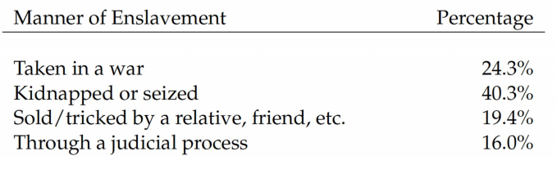

Conclusion:

-Intensity of slave trade between 1500-1800 is a powerful indicator of modern-day economic outcomes.

-Slave trade enacted a powerful reversal of fortune:

🡪 Countries that were more advanced in 1500 were targeted more intensely and those countries are among the least developed today.

-Slave trade affected economic performance through ethnic fractionalization, state building, trust.

**LECTURE 14: Institutions**

-Recall:

Why are some countries more prosperous than others?

Growth Theory / Development

🡪Factor Accumulation (Solow), Endogenous Growth (Lucas-Romer)

Ultimate Causes

🡪Geography, Culture, Institutions

Institutions: Humanly devised constraints that shape human interaction. They can be thought of as the rules of the game.

-Institutions refer to laws, rules, contracts, or other constraints that shape and constrain human interaction.

-Entities that perform specific tasks such as govn’t, banks and NGOs are called organizations.

Coase Theorem:

-In the absence of transaction costs, a market economy will produce an efficient outcome irrespective of initial allocations or legal entitlements.

-A literal interpretation of the Coase theorem means that governments need not interfere with the allocation of resources. (People who are more productive will buy resources from the less productive)

Example:

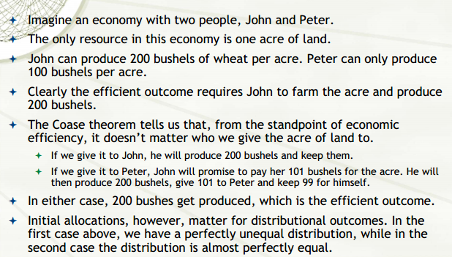

-The Coase Theorem however is costly due to transaction costs.

Economic Institutions

-Economic institutions determine how large are transaction costs, and who pays them.

-Good institutions are those that reduce transaction costs, allowing for a greater scope of economic transactions.

-Economic Institutions include property rights, legal systems, markets, tax/trade codes, insurance…

-Economic Institutions are the main determinant of the amount and distribution of resources in a society. They are endogenous meaning they are chosen by members of society per political power mostly for distributal consequences.

-Commitment problems prevent societies from choosing the institutions that maximize aggregate wealth.

-The distribution of political power is also endogenous 🡪 de jure political power (electoral system)

-The distribution of economic resources 🡪 de facto political power (ability to engage in collective action)

-Political power determines both political and economic institutions.

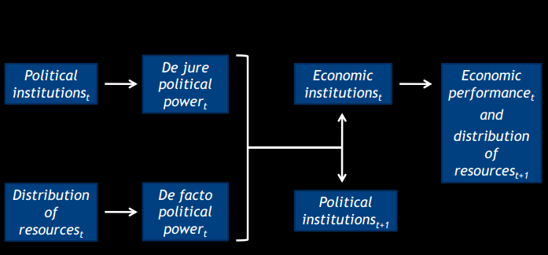

-Political institutions are slow-changing

-De facto political power determines future political institutions

-Holders of political power will bias the distribution of resources in their favour.

-Increases in economic fortunes of outsider groups can endow them with sufficient political power to challenge the established rulers.

Why do inefficient institutions persist rather than allow wealth-maximizing institutions to rise?

🡪Those holding political power cannot credibly commit not to use it to expropriate others.

An absolute monarch cannot credibly promise not to overtax merchants once they have sunk their investments and started to reap their profits.

-De facto political power is transient and exercising it requires solving collective action problems that may not be solvable in the future.

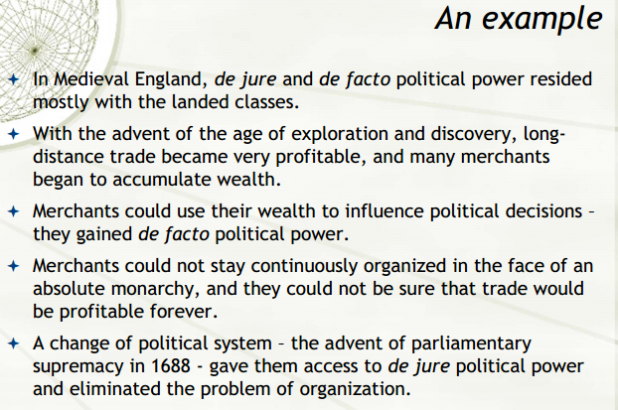

-Good economic institutions rise when political institutions place checks on power holders, power is spread across broad groups with investment opportunities, and there are limited rents that power holders can extract from society.

Measuring Institutions:

-Scored by various aspects assigned to features that reduce transaction costs

🡪 summarized with an index variable.

Examples: Protection against expropriation, rule of law, cost/time to incorporate a business, corruption in government, economic freedom.

-To find a relationship on the effect of institutions on economic growth, it is necessary to find an exogenous source of variation in institutions.

-AJR argues that institutional differences are key to why some former colonies are rich/poor.

-In places where Europeans could live, they imported their home institutions and migrated.

-Where Europeans were likely to die, they set up extractive institutions.

Political Coase Theorem View

-If bargaining is costless, institutions maximize aggregate welfare will emerge.

Ideology View:

-Well-meaning leaders differ on their view of what is good for society, and hence what institutions to implement.

Incidental Institutions View

-Institutions are determined by historical accidents, and then persist for a long time.

Social Conflict View

-Institutions are chosen by groups holding political power, not by society at large.

-Power holders will choose the institutions that maximize their own rents.

-Commitment problem rises when there is no way to enforce an agreement between an institution and ruling elite.

🡪 Causes holdup (elites cannot promise to expropriate investors and producers)

🡪Political losers (Ascending power groups cannot promise to compensate incumbents for relinquishing power)

🡪Economic Losers (Those who benefit from better economic institutions cannot promise to compensate those who would lose from them)

Efficiency and Distribution:

-Efficiency and distribution are inseparable.

Conclusion:

-Institutions matter for economic growth. They are endogenous.

-Institutions are chosen for their distributional consequences.

-Commitment problems make efficiency and distribution inseparable, thus are not efficient.

**LECTURE 15: The Mystery of Missing Information (Institutions II)**

-Economic systems are classified according to the ownership of resources and means of production.

-Communism: production owned by the state

-Capitalism: production owned by private individuals/corporate entities

-Mixed “Third” Way: State owns some and heavily influences/restricts economic activities

-Communist systems consistently failed to produce sustained economic growth and largely rejected.

-Capitalist systems have rapid grown in western countries.

-In many third world countries, there are many entrepreneurial bazaar merchants/street vendors.

-Vast majority of third world has assets like houses, vehicles, electricity, etc.

-De Soto calls these assets “dead capital”

🡪Assets that cannot be used in productive process (not mortgaged, subdivided, sold, etc.)

-Thus, these accumulated wealth is unable to engage in economic growth.

The Five Mysteries of Capital:

1. Mystery of Missing Information

2. Mystery of Capital

3. Mystery of Political Awareness

4. Missing Lessons of US History

5. Mystery of Legal Failure

-Before 1950, most people in developing countries lived in countryside working on land owned by a few very wealthy landlords.

-Machines improved productivity reducing need for labour.

-Highways made city access easier and TV brought information.

-Most people eventually settled in shantytowns as city population swelled.

-It was difficult for people to obtain legal title to new houses, businesses or find legal jobs.

-As people settled outside formal legal system, so did their assets.

-De Soto found that it took a long time and a lot of money to become legal.

Problem of Enforcement

-Once a person/house become extralegal, the formal institutions of state are not available for them.

-Enforcement is provided by authorities selected within the community.

-Thus economic activity is restricted to small circles of people who know each other well.

Measuring Dead Capital:

-Counting Houses (as they are hard to hide)

-At least 9.3 trillion dollars of dead capital.

-De Soto argues that the solution to many of the developing world’s problems lies in freeing up the potential of this dead capital.

Conclusion:

-Capitalism has made western countries rich, but failed to take root in the rest of the world.

-It is too costly for the poor to obtain legal title to their assets and maintain that legal title.

-Thus huge proportion of assets in developing world become dead capital.

**LECTURE 16: The Mystery of Capital**

Recall:

-We’ve seen that the poor of the developing world own substantial assets (houses, cars, tools, etc.)

-These assets are dead capital; meaning they cannot be pledged, mortgaged, sold or subdivided

-The word “capital” comes from Latin meaning “head” probably used to refer to head of cattle.

-Cattle is an example of capital. It grows overtime, reproduces itself, and can be used in the productive process (ie. Supplying power to till land, or provide inputs to dairy/hide industry)

-In developed world, assets also lead parallel lives, one as a physical asset and one was capital.

-Houses provide housing services 🡪 physical asset. However houses can also be mortgaged to finance a startup of a business, thus a source of capital that powers a company.

Adam Smith:

-The stock of assets accumulated for productive purposes.

-Makes specialization and division of labour possible.

-Division of labour increases the productivity of society

-Capital is key to wealth of nations.

-For accumulated assets to become active capital, they must be fixed and realized in some subject.

-Labour employed in the production of assets will not leave any lasting trace if not properly fixed as capital.

-Capital is not the stock of accumulated assets, but the potential it holds to deploy new production.

Karl Marx:

-Capital is the base of all production.

-Money itself is not Capital as it cannot produce anything. It is exchanged for capital.

-Money cannot make a cow produce milk for example.

Features of Capital

-Must be produced by human labour before becoming itself a factor of production

-Enhances a person’s power to perform economically useful work.

-It is not consumed in the production process

Example

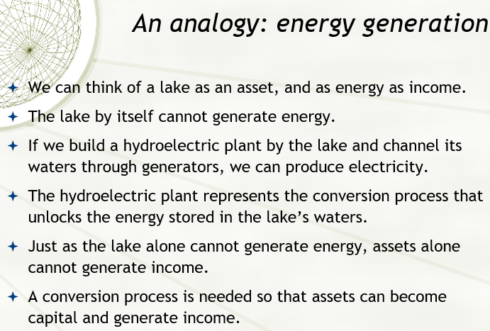

-A mortgage is a loan secured on an underlying asset.

-To determine whether banks can give a mortgage, they need to know who the owner of the asset is and how much it is worth. The bank also needs to know that they can seize the property upon failed to repay.

Example: Mortgaging House

🡪Bank runs title search with real estate registry. Legal estate will tell if the house is indeed mine, and from court system bank learns if I have any other lawsuits currently.

🡪Assessment office has copy of deed which lists economically relevant features of the house, and value.

-Depending on the legal system and law enforcement of the country, the bank will be able to claim the house as theirs.

-Deed: Describes economically relevant features of the house

-Registration: Legal owner

-Court Records: Establish house is free of liens

-Sales Agreement: Establish value

-Mortgage Agreement: Establish bank’s right to take house if I fail to pay.

🡪All together form the representational system

🡪Representational systems were designed to protect specific property rights.

-De Soto’s central insight is that representational property systems are key mechanisms that allow assets to be converted into capital.

6 Effects of Property:

1. Fixing economic potential of assets

-Property is a concept we have about an asset.

-Property documents record in writing economically/socially useful qualities of asset

-Title/Deed/Registration/Assessments are not qualities of house but representations

2. Integrating dispersed information into one system

-If property systems are not integrated:

-competing jurisdictions can render conflicting decisions

-many competing claims on an asset

-Integrated property systems reduce transaction costs and allow assets to become capital.

3. Making assets fungible

-Physical assets cannot be divided

-Property representations of an asset can be divided

-Property representation also allows you to combine assets

-Without property representations, assets remain indivisible.

4. Making people accountable

-Eliminate anonymity

5. Networking people

-Formal property representations identify people and link them with assets

🡪 Enables people and companies to locate and track other people.

6. Protecting Transactions

-Unified systems of property representation track/protect all property records

-Enable westerners to move large quantities of assets with few transactions.

-Money started off as debt notes

-Money re-supposes the institution of property.

-Money is used to measure capital

-Formal property systems were created with the purpose of protecting property, not transform assets into capital.

Braudel’s Bell Jar

-Capitalism existed in the west as if in a bell jar; isolated from the outside world.

-De Soto argues that the main reason is that only the West has formal property representation systems that allow assets to be transformed into capital.

Conclusion:

-Capital is the set of assets used for productive purposes

-Assets are fixed as capital through formal property representation systems

-These systems make assets measurable, fungible, and transferrable

-They also link people to assets, to each other, and make them accountable.

**LECTURE 17: The Mystery of Political Awareness**

-Migrants have been flocking to cities in the developing world

-Most migrants to cities in developing countries end up in the extralegal sector.

-Governments have several programs in place to try and deal with it, but typically react by moving people into housing projects and shantytowns, crack down organized crime for example.

-Governments fail to tackle the root causes of migration and extralegality.

-De Soto argues that we are in the presence of a “New Industrial Revolution,” that extralegals hold the key to a deeper division of labour to power economic growth.

Integrated Property Systems:

-The difference between the West and Developing countries lies in property systems

-Developing countries rely on many disconnected property systems, most of them administered extralegally.

-The West integrated its property systems at least 100 years ago.

-As extralegality grows in the developing world, property systems multiply instead of unify.

-Property Systems are networks of people and assets.

-Metcalfe’s Law: Value of network increases proportionally to the squared # of users

Mystery of Political Awareness:

-Political Blindness: Being unaware that the growth in extralegality is caused by a global movement from life organized in a small scale to life organized in a large scale.

-AS governments fail to update their legal systems to the new status quo, people spontaneously organize themselves in parallel property systems.

🡪 Results in fragmentation of property networks and consequences of assets not becoming productive capital.

Blind Spot #1: Life outside the Bell Jar (Today)

-Governments are not aware of the sheer size of extralegal sector in the first place.

-Governments and academics rely on data collected by govn’t stat offices 🡪 Miss extralegal sector

Eg. Peru Construction: Data showed industry was going down but cement sales were up.

🡪Construction companies stopped registering and applying for permits

-Better roads make it easier for people to move form countryside to cities.

-Agricultural modernization reduces labour requirements, thus depressing rural wages

-Cities have better health systems and better educational opportunities.

-Govnt treat extralegal as criminals, however extralegality is the poor’s escape to destitution.

-Extralegals cannot rely on law enforcement 🡪 have community based institutions only enforce agreements within group enacted with.

-Extralegals are at risk of exploitation from criminals and state officials.

Blind Spot #2: Life outside Bell Jar (Yesterday)

-This has happened before.

-Economic activity in early modern Europe was regulated by guilds. Membership was exclusive.

-Migrants were excluded and settled outside cities where their activities were less visible to law

-Migrants competed with guilds but gradually improved product quality and made cheaper

-Soon people from the city seeked their products.

-Guilds were outcompeted by the extralegal sector and govn’t understood that recognition of extralegality was the only solution. Legal frameworks were formed, opening up markets to competition and labour laws became more flexible.

Lesson:

-The expansion of extralegality signals a void in the law, a failure in the capacity of state to organize economic activity or protection of vested interests.

-Repression of extralegality does not achieve its objectives as it generates violence

-Solution lies in integrating extralegal activities to state’s institutional framework such as making property systems accessible to the poor and expanding the scope of recognized economic activities.

Conclusion:

-Extralegality has grown out of rural-urban migrations

-These migrations respond to structural economic reasons, and often cannot be stopped through political means

-Increasing extralegality results in fragmented property networks

-Govnts are initially blind to extralegality because data are focused on legal activities

-The solution to extralegality involves expanding the scope of law to integrate extralegal activities into unified property systems.

**LECTURE 18: The Mystery of Legal Failure**

-Integrating extralegal assets into a centralized property system is the key to unlocking the ability to generate capital. Govnts around the world have actually engaged in multiple efforts to expand the reach of legal property systems.

Misconceptions:

1. People in the extralegal sector avoid paying taxes

- Extralegals have to bribe police and protection from mafia/other people

- Extralegals have no economies of scale, financial instruments/logistic networks

2. Assets are extralegal because they have not been properly surveyed/recorded

- Govnts believe that if they had better mapping tech. they will reduce extralegality

🡪 This is false because most integrated property systems were done before computers

3. Legislating a procedure to register assets is enough, govn’ts can ignore the cost of legality

- Property is not a quality of assets, it is the legal expression of an economically meaningful consensus about assets.

4. Existing extralegal arrangements can be ignored

5. It is easy to change people’s conventions on how they can hold their assets.

- Social Contract: Economically meaningful consensus about assets turns property into legal recognition

Legal Challenge:

-Identify what assets are and who they belong to 🡪 “listening to the barking dogs”

-Mandatory law is not the answer was they don’t work for the poor. (Registration too long)

-Extralegal social contracts are almost always good enough as the basis of the law

🡪Mechanisms to describe assets, ownership, transfer assets, resolve disputes

Political Challenge:

-To lift the bell jar, it is necessary to overcome the resistance of vested interests

-Requires leadership

-To understand what extralegals face, it is necessary to walk in their shoes

-Providing the poor with property rights will enable them to enter capital markets

-The increased economic activities benefit the elites as much as the poor themselves.

Custodians of the Bell Jar

­-Lawyers (do not see problem with existing law), Bureaucrats (believe key is better information systems), Politicians (tend to protect vested interests)

Case Study: San Francisco Solano Settlement:

-1981 squatters occupied land in suburb of San Francisco Solano

-Subdivided into 300m^2 lots

-Settlers applied for legal title thinking it was public land, however it actually had 13 owners

-Govnt offered money to legal owners for the land, 8/13 became legal title, 5/13 were not.

-Effects: Families with legal title had improvements in their livings and those without did not.

-Children born to families with legal title have higher education, lower child pregnancy.

-Titled houses use their properties as a savings tool, knowledge they will be able to sell in the future

-Employment opportunities between both groups were the same

Conclusion:

-Govnts operate under serious misconceptions about the extralegal sector

-Successful efforts to integrate requires:

a) Identifying assets and social contracts (“listening to the barking dogs”)

b) Expand the law to recognize existing arrangements

c) Coopt the elite

d) Keep custodians at bay

-Requires stronger leadership

-Benefits of legality extend beyond property itself, positive educational and health outcomes

**LECTURE 19- Geography and Institutions**

-Acemogul, Johnson, and Robinson argued that geographic determinants of economic growth do not survive controlling for institutions.

Engerman-Sokoloff Hypothesis:

-Climate and factor endowments determine the optimal economic activity

-Colonizers select the institutions that could better support their activity

-Initial institutions were strengthened by elites who benefitted them

-Over the longrun these institutions determined the different growth paths of countries

Initial Colonization of Americas

-Focused on tropical territories (high native population density, high productive land, minerals)

🡪Extraction of mineral resources (Bolivia, Peru, Mexico), Production of tropical crops (sugar, coffee, tobacco, etc.)

-New England and Canada were colonized after the desirable territories were taken.

🡪Harsh winters

-More sparsely populated lands best suited to small individual farms.

Three Types of Colonies:

|  |  |
| --- | --- |
| 1. Plantation Economies: West Indies and Brazil | -Soils and climates well suited for cash crops  -Population dominated by imported slaves  -High Inequality |
| 2. Mexico and Peru | -Large mineral resources  -Large Native Population  -High Inequality |
| 3. North American Mainland | -Not suited for cash crops  -No large native population  -Land Abundance fostered independent holdings |

-Initial colonies had little labour. So Europeans enslaved local populations and imported African slaves.

-Migration to Portuguese, British, French colonies increased throughout 17th-18th centuries.

-Migration to Spanish colonies decelerated and stagnated due to restrictive immigration policies.

-Whites were a minority everywhere as African slaves made up majority of population (except Canada and New England).

-Europeans migrated to colonies where economic opportunities were most promising.

-Disease environment did not seem to deter the Europeans

-Plantation colonies had highest degree of inequality, followed by Spanish colonies and most equal were New England and Canada.

Role of Institutions

-Highly unequal societies are dominated by elite that seeks to maintain its position

- Created Legal frameworks advantaged the elites

- Immigration Policy was key

-More equal societies are characterized by inability of one group to become overly dominant

Land Policy:

-Homestead Act (1862) and Dominions Land Act (1872) allocated land to anyone willing to live there

-All societies restricted the vote to adult males until 20th century

-US and Canada eliminated literacy and wealth requirements on voting

-By 1850 every northern state in the US had laws requiring free primary schooling

-British Colonial Office did not begin to establish primary schools elsewhere until 1870

-Latin America invested in universal primary schooling to attract European Migrants.

-Farmers had access to vast network of community banks

-In rest of Americas, banks were heavily concentrated and functioned as a reserve for the elites

Two views of inequality and industrialization:

1) Inequality favours industrialization (Capital formation needs savings, only the rich save)

2) Equality favours industrialization (Development of extensive market networks, human capital accumulation)

Conclusion:

-Factor endowments determined initial wealth distribution

🡪 High inequality in highly productive/resource rich colonies

🡪Low inequality in sparsely populated, resource poor colonies

-Wealth distribution determined initial institutions

- Unequal societies adopted institutions that perpetuated and deepened inequality

- Immigration policy, land ownership, extension of franchise, education

-Inequality resulted in delayed economic development.

**LECTURE 20; Culture and Religion**

-Culture is the set of socially acquired norms, beliefs, values, and artifacts that influence human behaviour. Culture is often cited as a central determinant of economic growth.

-Religion is one of the central expressions of culture in the vast majority of societies.

-Max Weber: One of the 3 founders of sociology. He has strong links between beliefs, inequality, and economic performance.

-Weber noted that Protestant countries had better economic outcomes than Catholic ones.

Weber’s Thesis:

-Weber argued that Protestantism was a direct cause better economic outcomes.

-Catholicism: actions on earth determine your future and can be erased by confessing sins.

🡪 Education geared towards humanities than trades

-Calvinism: Salvation is personal and determined only by God.

🡪 Led to strong work ethic which translated into higher productivity and income

-Members of minority religion are excluded from political elites, thus engage in trades and follow productive activities to earn a living.

-Religion has a direct impact. You work harder because of moral imperative.

-Religion also has indirect impact: Acquiring skills making you more productive (trade education)

-Protestantism placed a strong emphasis on literacy 🡪 Reading the bible

-Becker and Woessmann argue that the effect of Protestantism on economic development can be explained entirely by increases in literacy

-Prussia is the birthplace of Protestantism (and Weber) provides ideal testing ground

-Institutionally homogenous

-Both Protestantism and Catholicism

-Excellent statistical records

-Diffusion of Protestantism can be tracked accurately

-Strong positive association between share of protestants in a county and literacy rate

-10% increase in protestants associated with increase in literacy

Instrumental Variables: Instrumental variable is a variable correlated with X but not Y, where X and Y possibly related

-Becker and Woessmann use distance to Wittenberg as an instrument for share of protestants in a county.

-Reformation started in Wittenberg

-German Historians observed that Protestantism diffused in concentric circles centered in Wittenberg

-Distance to Wittenberg is uncorrelated with any potential determinants of literacy

Data:

-Income Tax – Miss lower end of income distribution

-Share of manufacturing and service sectors

-Teacher income (financed from local contributions reflecting overall income of a county)

Effect of Literacy:

-Protestantism is a very strong predictor of economic outcomes

-Once literacy rate of population is added as a control, effect of Protestantism disappears

|  |  |
| --- | --- |
| C:\Users\Matthew\AppData\Local\Microsoft\Windows\INetCacheContent.Word\Untitled.png | C:\Users\Matthew\AppData\Local\Microsoft\Windows\INetCacheContent.Word\Untitled.png |

Was Weber Wrong?

-Higher Literacy was associated with better economic outcomes in 19th century

-Once effect of literacy is taken into account, there is no residual effect of Protestantism in itself

-Weber was right: Protestant areas did become more prosperous after the reformation

-Weber was wrong: identified the wrong channel to explain economic superiority of Protestant areas

Conclusion:

-Religious beliefs alone drove Protestants to work harder, take more risks, and engage in productive activities

-Becker and Woessmann showed that Protestants acquired more education

-Higher incomes of Protestants can be fully explained by their higher educational attainment

-Culture had an indirect effect 🡪 Through education

**LECTURE 21: CONCLUSION**

Inequality within Countries:

-Inequalities within countries has declined in recent history

-Cross-time comparisons are tricky. There are more to wealth than monetary units

-Socialist economics succeeded in reducing inequality but at the cost of lowering productivity and growth

-Regional inequality is a serious challenge to national identity

Inequality Between Countries

-Inequality across countries increased dramatically in the last two centuries

🡪 Developed countries have high living standards while many developing countries are in subsistence levels

-80% of a persons income is determined by country of birth and parent’s socio-economic status

-Migratory flows and pressures are the response to these differences

Development

-Kuznets curve postulates that as a country develops inequality first increases then decreases

-Engels’ Pause: Industrial Revolution required investment in capital intensive technologies 🡪 Increase in profits while wages stagnated 🡪 Investment done then wages grew

Trilemma of Globalization:

|  |  |
| --- | --- |
| a) Increasing Globalization  b) Large inequality across countries  c) Limited Migration | Only 2 can coexist in the long run:  i) Increasing globalization and inequality causes increase migratory pressure  ii) Continued large inequality without migration requires globalization to decrease  iii) Increasing globalization and limited migration requires reduction of inequality |

|  |  |
| --- | --- |
| Proximate Causes of Growth  -Guns, Germs, Steel  -Technology  -Human Capital Accumulation | Ultimate Causes  -Geography (orientation of continents, climates, species)  -Food Production and Animal Domestication  -Institutions  -Culture |

Institutions:

-Acemogul, Johnson, Robinson argue that institutions are ultimate cause of long-run growth

-De Soto provides an application on this 🡪 Difference between developed and developing countries resides in how their property systems allow assets to become capital

-Inclusive institutions are central feature of prosperous societies

Institutions and Geography Interact:

-Engerman and Sokoloff argue that geographic characteristics determined which institutions were chosen:

-Places suited to agriculture got elitist, extractive institutions (West Indies, Brazil, Mexico)

-More inhospitable places developed small farms, resulting better income distribution and

more inclusive institutions (New England and Canada)

-Institutions determined development path of countries

-Income inequality is also a determinant of long run economic performance, through its effect on institutions

Culture:

-Culture is the set of socially acquired norms, beliefs, values, and artifacts that influence human behaviour. Culture is often cited as a central determinant of economic growth.

-Culture can have strong effects through institutions or human capital accumulation

-Income inequality is one of the central problems of our age

-Inequality across countries reflects differential patterns of development

-Inequality within countries reflect power relationships

-High inequality poses moral and practical problems

-Low inequality comes at a high cost (reduction in incentives to innovate, restriction to freedom)